PASC EV Charging Paper (Updated) – May 2022

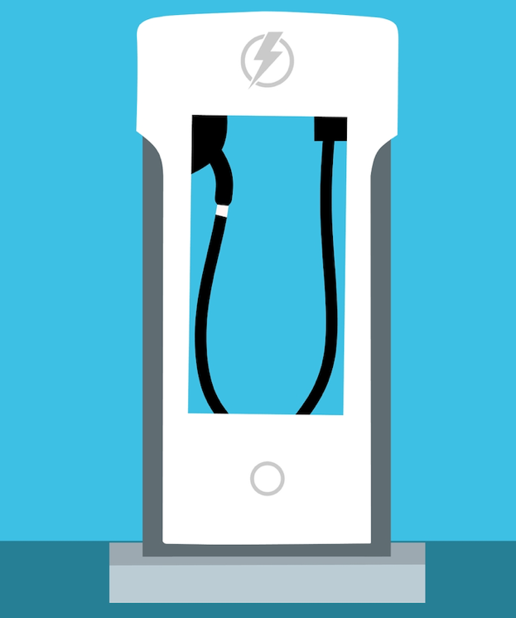

Electric Vehicles are fast becoming a fact of life and having an EV charging point in your holiday property can be a useful USP for attracting business. However, the environment is changing rapidly, and there is a lot to consider before making the investment. This paper is an update to the PASC UK EV Charging Paper issued in July 2021, and will cover some of the key considerations including
- Do you have the power? - EVCPs (Electric Vehicle Charging Points) draw quite a lot of power. This can create problems if you are close to the limits of what your individual system can deliver. If you also have hot tubs, air source heat pumps, electric showers, and other equipment with requirements for high power output, then you may not be able to add EVCPs without upgrading your supply cable (which may or may not be possible, depending on local supply, but also may not be cheap). Most houses are on a single phase fused at 60, 80 or 100 Amp. Make sure you check BEFORE ordering your unit(s), as an electrician will refuse to install a unit if it will cause you capacity to be exceeded. Unfortunately, some places (especially those far away from a substation) simply won’t have sufficient power to support EV charging
- Whether to charge guests – offering free charging was a great marketing hook when there weren’t many EVs driving around. Now, with a lot more on the road, and energy prices rising hugely, it may not be viable to offer all-inclusive pricing.
- Regulatory Changes – The Government is introducing new rules - The Electric Vehicles (Smart Charge Points) Regulations 2021 – which will come into effect as of June 2022. The Government's aim is to maximise the use of smart charging technologies, to benefit both consumers and the electricity system, whilst supporting the transition to EVs. To meet this aim, we believe they are encouraging consumer uptake of EVCPs (electric vehicle charging points) that have smart functionality and provide appropriate protection for consumers and the grid and meet the following objectives: grid stability, cyber and data security - safety and data privacy and interoperability
- How strong is your Wifi/Mobile signal? – The most straightforward way of charging your guests will be to install a charger which debits the guest’s credit card at the point of delivery without the need for intervention by the owner. Much like the “pay at pump” option at fuel stations. This requires a strong enough Wifi or mobile signal to enable the system to take card details. If it isn’t strong enough at the site where the EVCP is located, you won’t be able to charge the guests. Make sure you check BEFORE ordering a Wifi-enabled unit – you won’t get a refund if you install and it doesn’t work for lack of signal.
- Grants – What is available, under what conditions, and is it worth it?
- How to charge guests for charging – with just one cottage, this can be a straightforward flat fee addition to pricing, but if cottages are sharing chargers, you need to add technology to be able charge a specific guest
- Commercially available options for charging (different techs – tokens, apps, cards, etc), and supplier/contract details
- Insurance
- Appearing on Maps
- The PASC UK Buying Club

Do You Have Sufficient Electrical Capacity to add EVCPs?
This is something that many of us never even think of. We just assume that because we are on mains electricity, we can draw down whatever we need when we need it. However, typical houses are on a single-phase supply, and usually have either a 60 Amp, 80 Amp, or 100 Amp main fuse (depending on age and location). That corresponds to a maximum total power delivery to the property of 14kW, 18.5kW, and 23kW respectively. However, this isn't an absolute maximum - you can take quite a lot more than this for a few seconds (to cover the surge when something like a large motor starts up), and a modest amount more for several minutes (so boiling the kettle during the ad breaks won't necessarily crash the system if you were otherwise up against the limit). However, if you have neighbours (for example in a village/town location) you may also have more restricted supply. The supply companies may have an agreement to supply you and your neighbours with 18kW each, but they work on the assumption that not everybody will be using the full amount all the time. In fact, they only provide capacity in the distribution network for about 2kW per house, as this is (historically) usually enough to get by without problems when spread across a whole housing estate or village. However, as we start adding draws on the system that require a more sustained supply – such as ground or air source heat pumps and hot tubs – that calculation can start to look insufficient.
Because EV charging requires sustained periods of draw on the system (it will be running on full power for several hours until the car is charged), it is more like an industrial load than (for example) running the kettle or electric shower for short periods. So, when the car is on charge, you have less capacity for the other electrical appliances in your house (electric showers, washing machines, dryers etc). Any installer coming to fit an EVCP should assess the maximum demand before installing a charging point. The installer is also supposed to notify the local Distribution Network Operator (examples would be Western Power, Northern Powergrid etc – to find your regional DNO see https://www.nationwideutilities.com/service/dno-idno/), so that they know when the number of EVs in the area is increasing to the point that their 2kW per house trade-off is about to break down.
If you want more than one charging points, then you are much more likely to run out of capacity - if you started off with a 60 Amp supply and put in two standard 30Amp units then there would be nothing left for the rest of the appliances in the house (and the installer should have refused to do this). Your options then would be to:
- ask the Distribution Network Operator to increase the size of your supply – if the cable feeding your house has spare capacity, this could be achieved by changing the fuse to a higher Amperage; if you don’t have spare capacity then you might need to upgrade the cable supplying your property, which can be very expensive (we have examples from members who have paid over £35,000 to install a new 3-phase supply!). Depending on the size and location of your site, this may or may not be worth the investment.
- install smart charging points, which can balance the car charging against the other consumption in the house, or balance charging on more than one charging point. All EVs are designed to accept this (ie. variable charge rate instructions from the charging point), and the equipment is straightforward and not particularly expensive.
EV Charging Points need their own dedicated circuit – Regulation 722.311 of BS7671 (the British Standards requirement for Electrical Installations) states that a dedicated final circuit shall be provided for the connection to electric vehicles. This is because, when charging, Electric Vehicles often use full load hence the need for dedicated circuits.
Can’t Guests Just Charge From my Domestic Supply?
Most EVs are supplied with a cable with a three-pin 13 Amp plug (often known as a “granny charger”), which will plug into a domestic socket. A regular three-pin plug will draw a maximum charge of 3kW, which will add about 10 miles of range per hour of charging. Which is fine in theory if your guests just need a top-up after local journeys but is unlikely to give a full charge overnight. However, a proper charging point will have safety features and protections built in, and have a lower risk of fire and electric shock than using a domestic socket. Using an extension cable is definitely not recommended, as it increases the risk of fire. In addition, many insurance companies will not cover you for guests plugging their EV into your domestic sockets.
Why is it dangerous and why might it invalidate your insurance?
The technical and legal answer…..
The wiring regs (BS7671) have a very specific section in an amendment they made in February 2020 regarding sockets that may be used for EV chargers.
They must have one of:
- an earth rod mesh
- an earth rod network
- or an earth rod that has an extremely low impedance

They must meet the following requirements:
- They must not be connected to the PME (Protected Multiple Earthing) system that will be in place in most properties
- You must ensure a voltage of less than 70V rms between the vehicle and the ground.
- It needs be a specific type of socket that allows the full 13A to be drawn with no damage, perhaps over a prolonged period of time, (so not a standard 13-amp socket and one that has EV stamped on the back).
- You should never use a standard 13-amp socket as they are not rated for EV Charging.
- This socket must be marked as an EV socket.
- Each EV connection must have its own RCD-DD device which would disconnect the live, neutral and earth conductors from the vehicle in the event of a fault.

Without such safety protocols being in place the body of the car could become live at any point, a normal 13A socket could catch fire, especially if that socket is close to a window and is in proximity to soft furnishings or curtains.
There is an explanatory video here https://youtu.be/KQEFy6tPUa0?t=1141 which goes through the EV charging section of the regs.
In the video at https://youtu.be/KQEFy6tPUa0?t=1722 There is a section on the specific type of outlet to be used.

A further video linked to that one shows the problem when a protective earth / neutral connector is broken https://youtu.be/KQEFy6tPUa0
There is also the document that can be cited which is the amendment to the regs: amendment1_read-only_final.pdf (theiet.org)
PASC UK Comment
To protect both your business, property and your guests and to maintain insurance cover it is essential that a properly installed EV Charging point is installed by a reputable qualified installer.
We would also strongly recommend making your EV charging rules at your property clear to your guests, especially if you do not currently offer professionally installed charging options. Perhaps by making it clear where the nearest charging station are.
Free Image to use near sockets that may be sued for EV Granny Charging

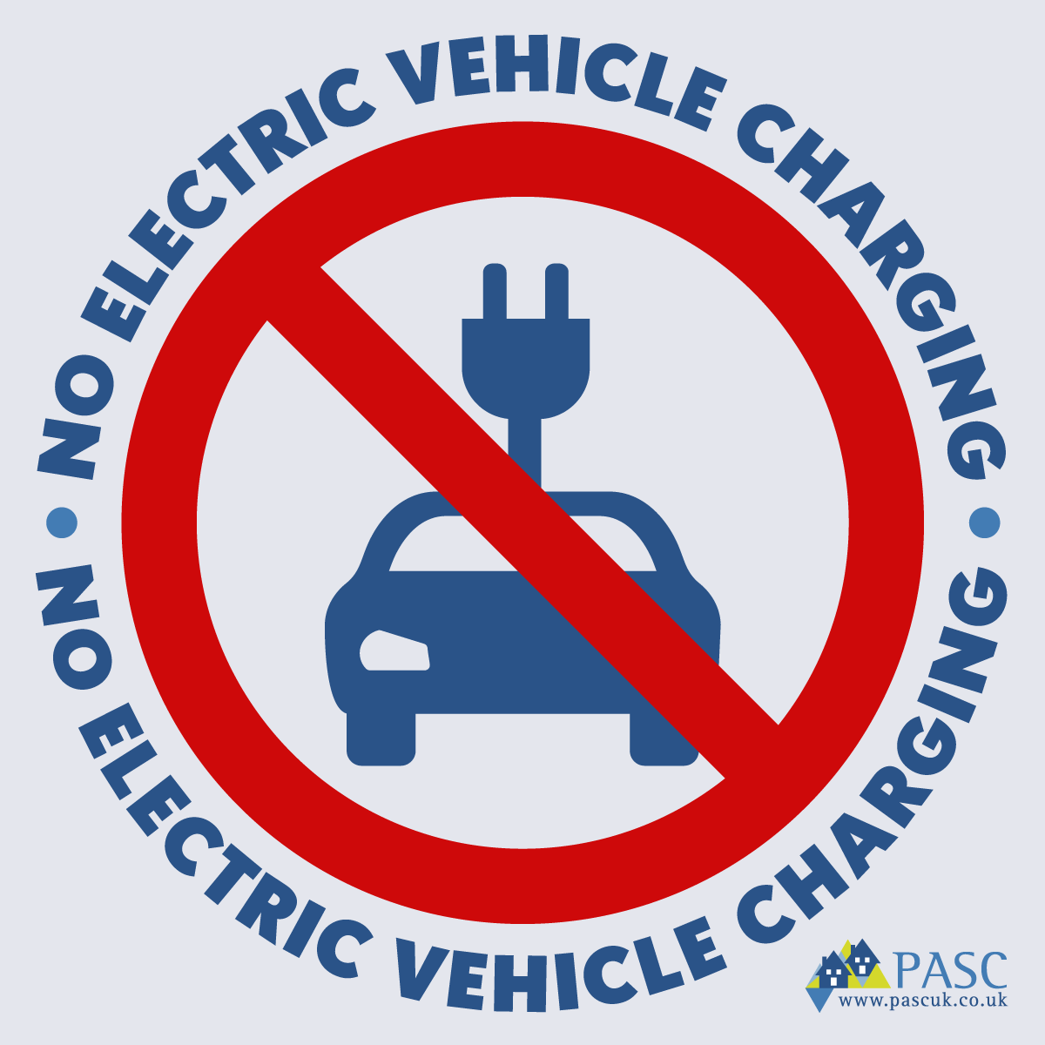
What Are the Different Speeds of Faster Charger?
In addition to the slow/granny charging (at 3kW), there is also “Fast Charging” and “Rapid Charging”
- Fast charging
A 7kW charger will usually take about 3-5 hours to charge an EV, while a 22kW unit could deliver a full charge in a couple of hours. These are the type you typically find in supermarket car parks and shopping centres. They will work with 16A or 32A single-phase electrical supplies. To install a 22kW charger, you would need to have a three-phase electricity supply. Most residential properties in the UK only have single-phase supply and cannot use a three-phase 22kW charger. You can apply for an upgrade to three-phase supply through your DNO, but this could cost you up to £15,000 (or more, depending on location, distance from the supply etc).
- Rapid charging
A rapid charger can be rated at anything from 11kW to 120 KW and can deliver 60-200 miles of range in 20-30 mins. Rapid Chargers will need 32A or 60A 3-phase power supply (the ultra-rapid chargers require DC supply, which is not used in domestic settings). In general, higher power levels will charge quicker. These may be an investment worth considering for larger complexes.
Should I Charge My Guests?
Two or three years ago, when more holiday cottage owners started installing EV charging to attract guests, there were relatively few EVs around. Having an EVCP certainly got a few extra bookings (which was the object of the exercise!), but it wasn’t a regular occurrence. Now, those with EVCPs can often find that they have not only one vehicle plugged in regularly, but often two or more guest EVs competing for the same supply. However, prices of electricity – particularly if you are on a commercial supply – have risen significantly. In 2021, the average price of electricity for businesses was 14.40p per kwH - https://www.businesselectricityprices.org.uk/cost-per-kwh/. We have heard of current (March 2022) new quotes for business tariffs are in excess of £0.60 per kwH, representing more than a fourfold increase in costs. Higher demand for EV charging - at much higher prices than last year - obviously makes for a persuasive argument to charge guests. After all, you don’t offer free diesel/petrol to your ICE (Internal Combustion Engine) guests. While free charging was a very attractive marketing hook, the mere fact that a holiday cottage has on-site charging is in itself an attraction, as “range anxiety” is very real, and many holiday areas have poor charging infrastructure.
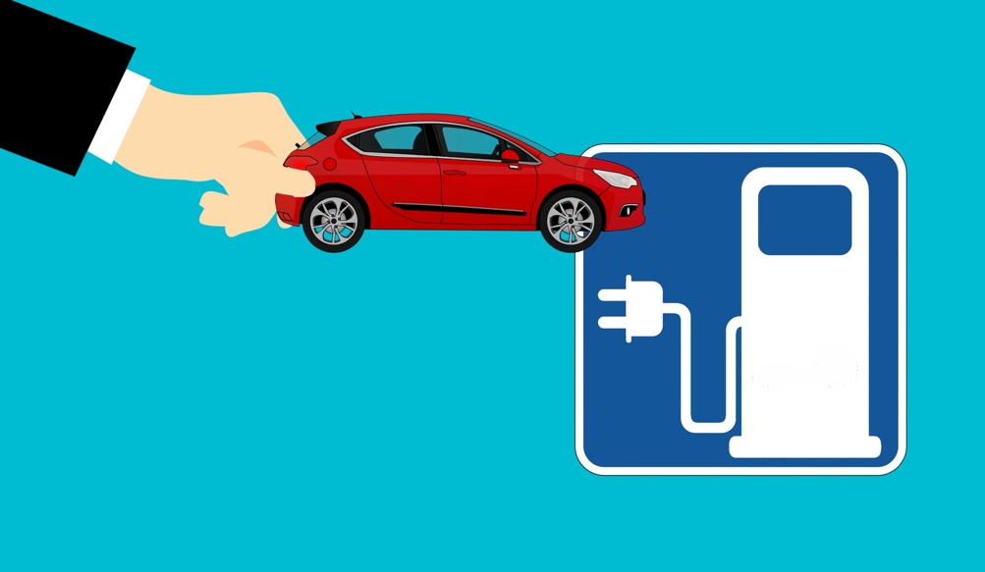
If you are going to charge, then you need a mechanism for doing so. If you only have one cottage, then it can be relatively straightforward, for example adding an optional fixed fee per night for EV charging to your booking form. However, if you have multiple cottages and one or more chargers, then it becomes more complicated to work out who is using which charger when and for how long. It then makes sense to have a “smart” meter, which will enable you to offer the equivalent of a “pay at pump” service to your guests. There are various options available, some involving tokens or cards (which would require interaction with the guest, which may not be practical – particularly if the owner does not live on site - and cards/tokens are easily lost), and others which will “release” the charger for use on authorisation of a credit card via an app. This will require reliable broadband/4G signal in order to operate effectively.
Regulatory Changes
One of the main challenges of the growth in EVs is how the electricity network will manage the rapid increase in demand, and the potential change in electricity consumption patterns on the grid which will result from a large electric fleet. In December 2021 the Government enacted new regulations - The Electric Vehicles (Smart Charge Points) Regulations 2021 – which come into effect from 30 June 2022. As of that date, all new installations of charge points will be required to have smart functionality, allowing the charging of an electric vehicle when there is less demand on the grid, or when more renewable electricity is available. Without smart charging, the risk is that rapid growth in demand (due to growth in the EV park) could overwhelm the National Grid at peak times, as everyone arrives home and plugs in their EV at the same time (e.g. between 5pm and 7pm). Without intervention, this would require significant levels of additional investment both in the networks that transport the electricity, with the costs borne ultimately by consumers, and in electricity generation capacity to meet increased demand. By making EV smart charging mandatory (for new installations), charging can be shifted to a different time of day (e.g. overnight, when there is less demand on the system; or to times when there is a high level of renewable energy generation). This can help reduce the immediate need for costly electricity network reinforcement to meet increased demand from EVs, and offers benefits to consumers too, including savings on their energy bills, as “off peak” tariffs (such as Economy 7, or Octopus Agile) tend to be cheaper (and in some cases can be zero or even negative – i.e. you get paid to take the power).
The new regulations also ensure that charging points meet certain device-level requirements, enabling a minimum level of access, security and information for consumers.
The main requirements of the legislation are:
- smart functionality, including the ability to send and receive information, the ability to respond to signals to increase the rate or time at which electricity flows through the charge point, demand side response services and a user interface
- electricity supplier interoperability, allowing the charge point to retain smart functionality even if the owner switches electricity supplier
- continued charging even if the charge point ceases to be connected to a communications network
- safety provisions, preventing the user carrying out an operation which could risk the health or safety of a person
- a measuring system, to measure or calculate the electricity imported or exported and the time the charging lasts, with visibility to the owner of this information
- security requirements consistent with the existing cyber security standard ETSI EN 303 645
Charging points must also:
- incorporate pre-set, off peak, default charging hours and allow the owner to accept, remove or change these upon first use and subsequently
- allow for a randomised delay function
The full requirements are outlined in the regulation, which can be found on the following link - https://www.gov.uk/guidance/regulations-electric-vehicle-smart-charge-points
Can your WiFi signal support Smart Charging?
From 30 June 2022, suppliers will not be allowed to sell non-smart charging points. To support a smart charging point, you will need access to the internet, either via WiFi or a 4G connection.
Installation manuals for smart chargers will advise that when choosing the location for your charging point, you need to check carefully that there is sufficient signal there. We have heard from some members that while the chosen site for their ECVP showed 3-4 bars of signal on their phones, the charging unit once installed could not achieve a stable connection, and they had to add ethernet cable. Which may be fine/straightforward if it is a relatively short run, but can become expensive if you suddenly have a requirement for additional trenchwork AFTER you have run your electric cables. It is worth checking which provider your chosen unit uses for the 4G connection (if using mobile rather than wifi) as you can definitely experience variable connectivity in some areas depending on the provider. Rural locations often experience similar problems with “smart meters” for their electric supply. While they may get an OK Vodafone signal (for example) at their site, but a poor EE signal, the smart meter may not work if they use EE as the provider for the mobile signal. Some manufacturers (e.g. ROLEC) use an amplify SIM, which can operate off any network and will search for the strongest signal. If you are on a large site, it may also be the case that the signal is fine in the house, but not at the chosen location for the EVCP, so it is important to know how reliable the signal will be at the point of delivery before purchasing and installing the unit.
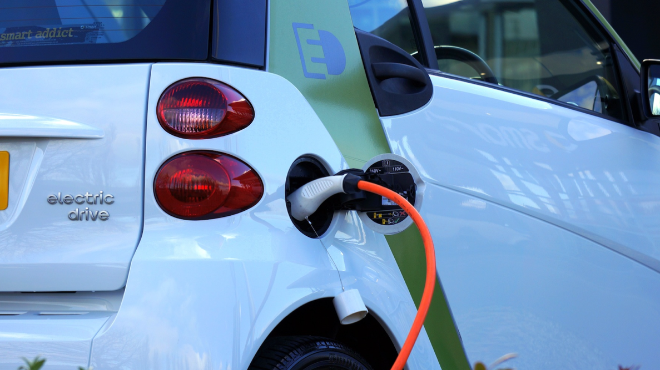

What Grants are available for the Installation of EVCPs in Holiday Cottage Settings?
Grants were previously made available for home charging, and for employees in a workplace. Up until April 2022, most hospitality businesses would not have qualified for a grant for installation of EVCPs as the available grants only covered your own car (and VIN plate number was required), or a Workplace Charging Grant for employees (which very few of us would have qualified for).
From April 2022 a new grant has been made available that most self-catering businesses can apply for. The domestic scheme is still available to those who live in flats, and tenants who rent (but don’t own, or have a mortgage on) their property. Again, this is unlikely to enable most self-catering operators to tick this particular box, as FHLs wouldn’t qualify for the “rented accommodation” grants (these have to be applied for by the tenant, and a VIN number provided). The Workplace Scheme is still available, but few self-catering businesses will be able to comply with the criteria.
NEW GRANT Available from April 2022 for accommodation providers
On 29 March 2022, the Government updated their grants policy to enable holiday and short stay accommodation to apply for a grant of £350 per charging unit. There are conditions that need to be met, and it won’t necessarily be given to all applicants unless they are able to meet the criteria.
Details here:
https://www.gov.uk/guidance/workplace-charging-scheme-guidance-for-charities-and-small-accommodation-businesses
The criteria is as follows:
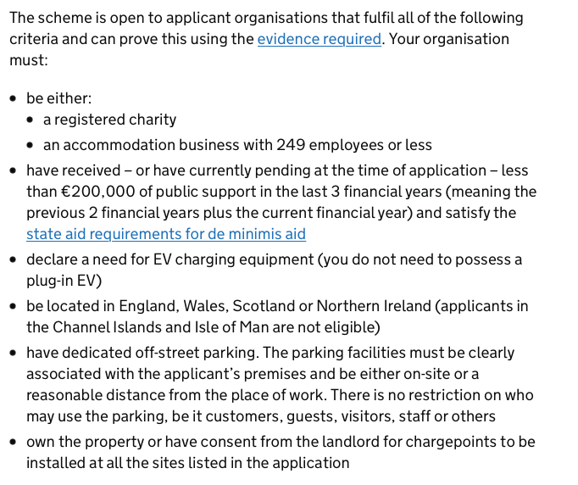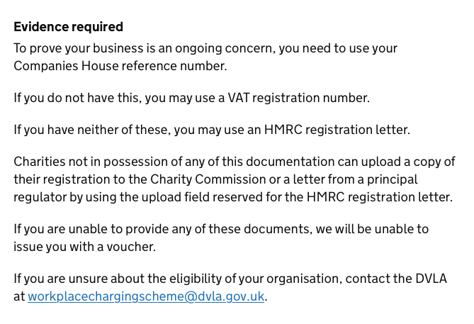
HMRC Registration Letter
Having contacted the team that deals with EV grants at HMRC for clarification on what an “HMRC Registration letter” might be, we received the following response:
An HMRC letter would be a letter in the business’s name and address and would normally have the tax reference number on it (UTR number). The details attached to the letter will have to match the details provided when applying for a workplace charging scheme voucher in order for the voucher to be approved.
You must make sure that your application is made in the name that is shown on the letter from HMRC, your UTR (Unique Tax Reference) number is on it and that the address you’re applying for matches the address on the letter.
The above quote also applies to the workplace grant below
Current Homecharge Scheme
This grant can now only be applied to those that meet this eligibility criteria:
Full details here:
https://www.gov.uk/government/publications/customer-guidance-electric-vehicle-homecharge-scheme/electric-vehicle-homecharge-scheme-guidance-for-customers
The Workplace Grant
There is also a Workplace Grant, which is intended to support the installation of EV charging for staff and delivery vehicles, but NOT for customers, which is what we are really looking for. This may still work for some of the larger businesses.
Full details here:
https://www.gov.uk/guidance/workplace-charging-scheme-guidance-for-applicantsv
Criteria as follows:
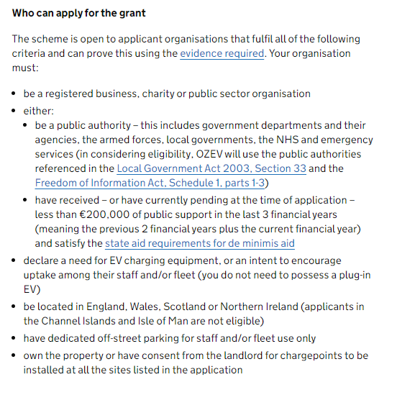
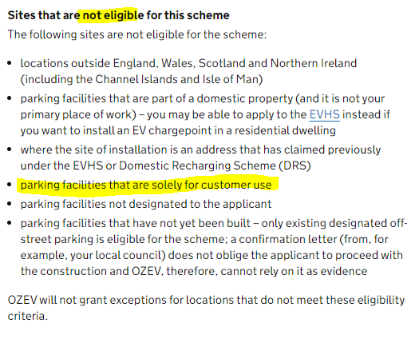
What are the Options for Charging Guests?
Non-smart charging
If you currently have an EVCP and don’t want to (or can’t) upgrade to a smart charger, then you still have some options. With just one cottage, this could be as simple as a straightforward flat fee addition to pricing (which you could build into your booking page as an option), or a “fair usage allowance” per stay (which would require a degree of owner intervention in terms of meter reading, and assumes a dedicated meter for the charger). However, if you have multiple cottages sharing chargers, you are likely to need to upgrade and add technology to be able charge a specific guest. If you are planning on charging on a “best guess” basis, then you will need to know the battery size of the car, and the tariff you are being charged. The cost to fully charge (from empty) an electric car can easily be worked out using the following formula
Electricity Tariff (e.g. 30p/kWh) * Battery size (e.g. 40kWh)/100 = cost (here £12.00)
Obviously, the current volatility in commercial electricity prices could make a significant difference to your cost, depending on the rate you are paying. If you were lucky/smart enough to lock into a lower tariff of 16p/kWh in January it will be relatively low, but current commercial rates for new contracts are being quoted at upwards of 60p+/kWh. If you don’t want to lock into a high rate (because you think rates may come down), and accept the Standard Variable Rate, you could be paying a lot more per kWh. We have reproduced below the cost at the two extremes to give an idea of the margin surrender of an “all inclusive” holiday rate if your electricity rate gets changed because it goes off contract. Also be aware of what your T&Cs were when the guest booked – if they booked a holiday for 2022 which was inclusive of free charging at the time of booking, you (sadly) can’t suddenly spring a big bill on them, unless your T&Cs included a clause saying you reserve the right to change pricing if fuel/power prices increase (much as the airlines do). Most of us will not have this in our T&Cs, so we will just have to absorb the cost, and change T&Cs for future bookings. If your tariff includes both a day rate and a (lower) night/off peak rate, then you could ask guests to only plug in during the off-peak hours, so you are charged at the lower rate.
The numbers below look rather scary if you multiply by seven and assume they recharge daily, but remember it is unlikely that most guests will be returning to their cottage with zero charge, and charging fully every day of their holiday. They will usually be using your charger to top up on a daily basis. However, it all adds up.
Car Battery Charge@ 16p/kWh Charge@ 60p/kWh
Nissan Leaf (2018) 40 kWh £6.40 £24.00
BMW iX3 (2021) 80 kWh £12.80 £48.00
Tesla Model X 100kWh £16.00 £60.00
Smart Charging – Commercial Options
Disclaimer – This paper has no ambitions to be a “Which” report on which technology or charger owners should buy. It is only intended to outline some of the technologies currently available on the market. Some of the information has been gained from PASC UK members who responded to the questionnaire, so will be anecdotal, and none of this information replaces the requirement for anyone considering installing a smart EVCP to do their own research. There are many options that a decent Google search will call up. Always check the reviews and the terms and conditions of the installations.
It’s impossible to come up with a standard figure for an installation cost, as so many circumstances vary. You may need a long trench digging to put the charger in the right place, you may need to upgrade a distribution board. Your requirements for a single cottage, or a multi-cottage complex will be different.

The ballpark figures quoted by Members during our original research (in 2019/20) was that a good quality car charging units averaged £500, and installations averaged another £500. However, these prices were for “non-smart” units, and mainly for average domestic-style installations, so should not be used as a guide for current pricing for smart units. The total installed cost will depend on a number of factors, including the unit(s) you choose, your current electricity setup, the distance of the EVCP from the consumer board, etc.

Getting multiple quotes from reputable suppliers would be the best next step.

PASC UK Members can get a discount from ROLEC for the supply of the chargepoint units. ROLEC manufacture the product in the UK. You will need to quote your business name so that ROLEC can check with PASC UK whether you are a member, in order to apply the discount. Members will also need to be registered with the Buying club. See note at bottom of Paper.

ROLEC Contact:
Darren North
National Sales Manager
darren@rolecserv.co.uk
www.rolecserv.com

ROLEC – - www.rolecserv.com - has several options with pay-to-charge technology.

The units have an amplify sim card in them which uses all major networks and attaches to the strongest one at that time. It the signal is not strong enough in the location where you are siting the unit to guarantee connectivity, then they would recommend having the smart OCPP units connected by ethernet for a constant connection.

- Largest range of charge point solutions in the UK, with solutions suitable for domestic, commercial and public charging
  - Single phase and three phase charging solutions
  - Single and dual outlet unit options
  - AC (fast-superfast) & DC (rapid-ultra rapid) chargers
  - Built-in TruePen options, negating the requirement for an earth rod which reduces installation time and costs
  - Smart load management options - avoid overloading your electricity supply
- Various activation methods
  - IOS & Android friendly mobile app
  - Web browser option (guest use without the need to register)
  - RFID activation
  - Reception controlled activation
  - Simple plug and play
- Full control of your network (smart options)
  - Display chargers on the VendElectric app or remain hidden and provide only approved users with access
  - Free vend charging
  - PAYG billing by either per hour or per kW
  - Monitor charge point uptime, utilisations, revenue and much more
Easee Charging - https://easee.com/uk/commercial-buildings/
- Charge points can be daisy-chained (so adding more points is easy and doesn’t require an additional supply)
- The points can deliver up to 22kw each (and can be load-balanced and adjust as cars plug in / finish so multiple points on the same supply will not overload the fuse board)
- There are multiple options for access, including:
  - An RFID card (possibly per property?) to allow charging (free/chargeable)
  - Monitoring software in the case of the above so one could raise an invoice for the power used at the end of a stay (or return the unused portion of a pre-payment)
  - Access via a free-to-download app which charges per kw-hour used. The app handles the billing process, deducting 10% for costs then returns the balance to the property owner. You can set the rate. This also distances the owner from the payment side – you make the EVCPs available, but are not seen as selling the electricity which is being handled by another organisation much as EV-owners are used to wherever else they go. Guests are free to use this or to use other commercial points
Project EV - https://www.projectev.co.uk
- Pro Earth charging range eliminates the need to install any additional earth spike, which means no extra costs & an easy install.
- Project EV chargers work in harmony with solar panel technology, meaning you can charge your vehicle using the green energy generate by your solar system.
- Secure your charging cable with Project EV’s cable lock system. Lock your originally untethered cable to your charge point and vehicle, ensuring user peace of mind, and full protection.
- All Project EV AC chargers have the ability to dynamically load balance, ensuring that the power of your household is distributed evenly across all your electrical appliances.
- Project EV chargers with a dual gun, or triple gun, outlet have the ability to charge multiple vehicles simultaneously.
- The entire Project EV range comes with onboard RCBO isolation as standard. Enabling you full electrical protection, ready out of the box.
- The FREE Project EV App allows you to choose and customise charging rates, prioritise off-peak charging to maximise savings (including via a solar charging mode) and create charging records; so you can see and control all your data.
SyncEV - https://www.syncev.co.uk
- Domestic and commercial chargers
- Works with a downloadable App (guest needs to download)
- Owner gathers guest email to authorise their use
- App records usage, and guest is charged accordingly
- Requires owner intervention (invoicing for usage)
Insurance

Maintaining your insurance cover whilst offering EV charging points is an important consideration, so it’s probably worth starting here with a note from a sample insurer, (the biggest risk is Fire), as covered in the early part of the Gallagher Cottagesure Document:

The majority of electrical fires are caused by incorrect use or poor maintenance of electrical installations and equipment. 26% of accidental fires in the UK are attributed to faulty equipment and their leads. The Electricity at Work Regulations 1989 requires that all electrical systems shall be of such design, construction and installation as to prevent danger.

Electric Vehicle Charging

The increasing use of electric vehicles has necessitated the provision of charging facilities which, if not managed appropriately, can introduce ignition sources and additional risks into the premises.

All chargers, not fitted with a 13amp plug, should be installed by a competent electrician such as those recognised by the NICEIC, the Electrical Contractors Association (ECA), the National Association of Professional Inspectors and Testers (NAPIT), or SELECT in Scotland.
Where 13amp standard plugs are in use dedicated external sockets, suitable for the environment, should be provided.
All chargers and associated equipment should be installed, used and maintained in accordance with the manufacturer’s instructions. Servicing and maintenance should be carried out by a competent engineer.

The installation/provision of Residual Circuit Devices (RCD’s) should be considered

Further information can be found in the document “RC59 – Risk Control – Fire Safety when Charging EV’s on the link here: https://bit.ly/3xso6rK

Under Electrical Provisions the RISC Document says:
- Where rapid charging points – known as DC fast charge and operating at 500V DC – are provided, they should be clearly differentiated from conventional charging points because of the hazards associated with the direct current. (5.5.2)
• A circuit intended to supply an electric vehicle must be fit for purpose and suitable for the electrical load. The circuit should be dedicated to the use of the chargers, and not be part of a ring main or used for other purposes. (5.5.5)
- An RCD should be installed by a competent electrician as additional protection for vehicle charging supplies.
There is lots more in there suggesting that doing this properly is a really good idea. We asked our electrician, to highlight the problems, particularly with ‘charging through a window’.
- The lead can become damaged through regular use, and constantly being taken in and out of a car boot.
- The circuit being plugged into must be a dedicated circuit, and be protected by a 30MA RCD

PASC UK Comment. If you have EV’s it should form part of any property Risk Assessment, and Guests should have clear instructions as to use and forbidding charging through windows.

For further safety information on the use of “Granny charging” cables, please see the following video:

https://youtu.be/No04dF7cwDc?t=306

Installing these devices properly is a must, you could well be putting guests and your property at risk otherwise, with the additional risk of not being covered by insurance.

If anything happened as a result of an insufficient or faulty installation to the Guest’s vehicle, or they tripped over cable, Guests will soon forget any ease of charging or free electricity as they sue for damages. This is when you need your insurers and your liability cover to come into effect.

It is well worth while explicitly forbidding the charging of EV’s through windows at your property in your Terms and Conditions.

For further money saving advice the same video linked above for safety information, shows some calculations regarding charging EV’s, but it is a little outdated and you will need to use your own tariff costs in any calculation you do.

https://youtu.be/No04dF7cwDc

Appearing on maps

There are pros and cons off appearing on the various EV map sites. The general consensus from the feedback from Members is don’t. Many have reported EV drivers suffering from ’rangitis’ desperation in the middle of the night and ringing to try and get their car charged. Appearing on maps such as the Tesla map is possible with a note that it is for customers only, but we have also had late night desperation calls.

Much better to make sure that at least some of the sites that you advertise your property on has a search option for EV’s.

If you did want to advertise on these maps here are some examples. Members have noted that getting off some of these once on can be tricky.

https://www.zap-map.com/
https://www.carwow.co.uk/electric-cars/charging-points#gref
https://www.plugshare.com
https://www.tesla.com/en_GB/supercharger

There is a page on the Tesla site that allows you to apply to become a Tesla partner. They used to be very proactive in supporting installations, now they ask the direct questions as to ‘what value will you bring to Tesla?’ Bottom of this page: https://www.tesla.com/en_GB/charging

Tesla owners use the Tesla charging map and you can specify for ‘patrons only.’

Investment in Car Chargers is Reclaimable.

Finally, our accountant tells us that there is 100% tax deduction for the costs incurred in the year of installation for EV charging points at a business.

How to join the PASC UK Buying Club

The Buying Club is only available to paid up PASC UK Members. There will be no additional fee for Members to join the Club, and almost 700 have already signed up.

To take part in the scheme, which is free to PASC UK paid Members, all you need to do is register your interest here: https://www.purchasingforbusiness.co.uk/

You will receive a simple form asking for your business details. When putting in your business name, put PASC UK afterwards. e.g., Higher Wiscombe Ltd/PASC UK. This will help Gurvinder and his team spot that you are PASC UK Members and send through a list to us for confirmation.

As soon as we confirm that you are members, you will be contacted by the Buying Club and get your discount cards.

The list includes the following:

- 5% Screwfix Discount
- 10% B&Q discount
- Beds (Mattisons & Sleepeezee)
- Bedding (Gailarde & Star Linen)
- Small appliances (Stearn Electrics)
- Janitorial & Cleaning (Pattersons & Alliance)
- Electric Vehicle Charging (ROLEC
- Hot Tubs (Master Spa’s)
- Card Processing (Worldpay)
- Outdoor Furniture (LeisureBench)
- Lighting (The Light Solution)
- Inventory & welcome packs (Pattersons)
- Sofa Beds (Hall & Letts)

Useful Notes

1/ Here’s a guide to calculating how much energy each type of Electric Vehicle takes to charge, from which you can the extrapolate costs of charging.
https://ev-database.uk/cheatsheet/useable-battery-capacity-electric-car

2/ Here’s a guide for those thinking about buying an electric vehicle from Honest John.
https://www.honestjohn.co.uk/guides/best-electric-cars/
